Learning cycle 1

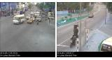

Learning cycle 2

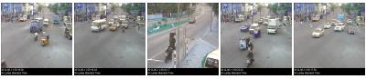

Learning cycle 3

With five input files (three layers putting same inputs)

Getting the first 350 frames

SF=8.9

Iterations =400

Hit threshold =0